2021 Mustang Mach 1
Shaker Cold Air Intake System

Part #2111-7000-01
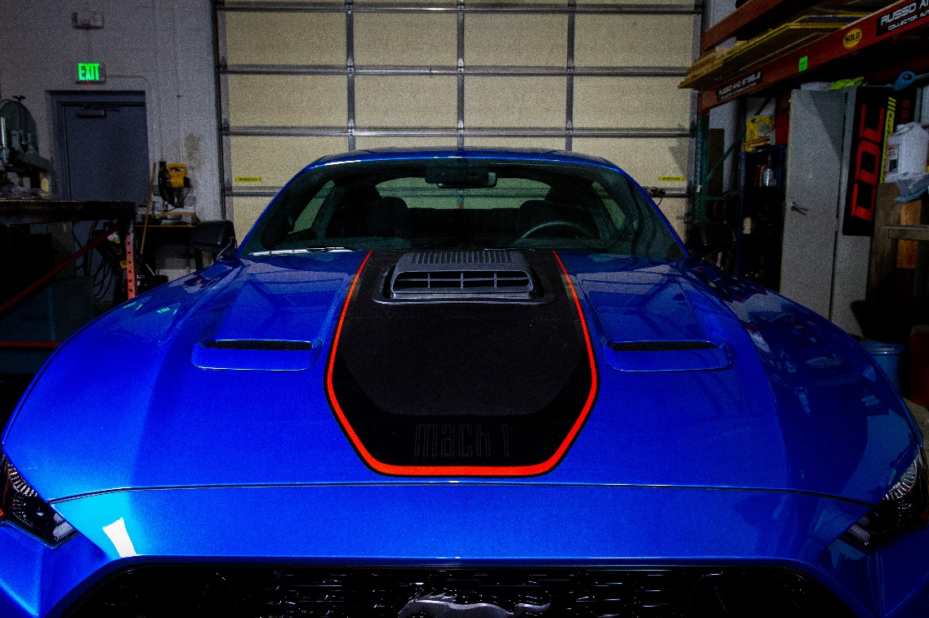
Component Check List:
Shaker Assembly: Part #
- 1 - Aluminum Shaker Scoop 183020a
  - 1 – Upper Air Box 1111-3301-01
  - 1 – Water Management Tray 1111-0500-01
  - 1 - Lower Air Box 1111-3300-01
  - 2 – M6-1.0 x 60mm Bolt 30009
  - 2 – M6-1.0 x 35mm Bolt 15005
  - 1 – Front Mounting “L”Bracket 2111-3500-01
    - 4 - M6-1.0 x 22mm Bolt 410109
    - 2 - M6 Washer 183005
  - 1 – Manifold Bracket 2111-3502-01
    - 2 – Ball Stud Receiver 183000
    - M6-1.0 Nutsert 50007
- 1 – Rear Mounting “Z” Bracket 2111-3501-01

Separate Components:
  - 1 –Trim Ring 2111-2106-01
  - 1 –3” Flexible Air Tube 8741
  - 1 – 3” Coupler w/ clamps 115056
  - 1 - Drain Tube 115058
  - 1 – Hood Template
  - 1 – Installation Instructions

Hardware Kit:
  - 3 – Aluminum Spacers .482” 57002
  - 1 – Aluminum Spacers .4375” 57003
  - 1 – Aluminum Spacers .375” 57004
  - 1 – Aluminum Spacers .25” 57005
  - 2 – Alcohol Packs 950006
  - 1 – Adhesive Promoter 950007

Note: Read installation instructions before starting. Test fit components before painting. The molded Shaker Hood Trim Ring is UV Stable, ABS Plastic and does not require paint. If you chose to paint the Shaker Hood Trim Ring, have your Trim Ring painted by a professional automotive painting facility to ensure the quality of your vehicle and the product. We recommend that paint-curing temperature not exceed 180°F.

Tool List:
- Masking Tape
- Fork Tool
- Straight Edge
- Scissors
- 3/32” Drill
- 1/8” Pilot Drill Bit
- 3/8” Drill
- 3” Hole Saw
- Drill Motor
- Jig Saw with metal blade (for cutting hood)
- X-Acto Knife
- Eye Protection
- 10mm Socket ¼” Drive
- 8mm Socket ¼” Drive
- 11 mm Socket ¼” Drive
- ¼” Drive 6” extension
- ¼” Drive Ratchet
- Tape Measure

Preparing:
- Raise Hood and remove under hood blanket, use a fork tool to remove pushpin fasteners. Set hood blanket aside. The hood blanket will NOT be reinstalled.
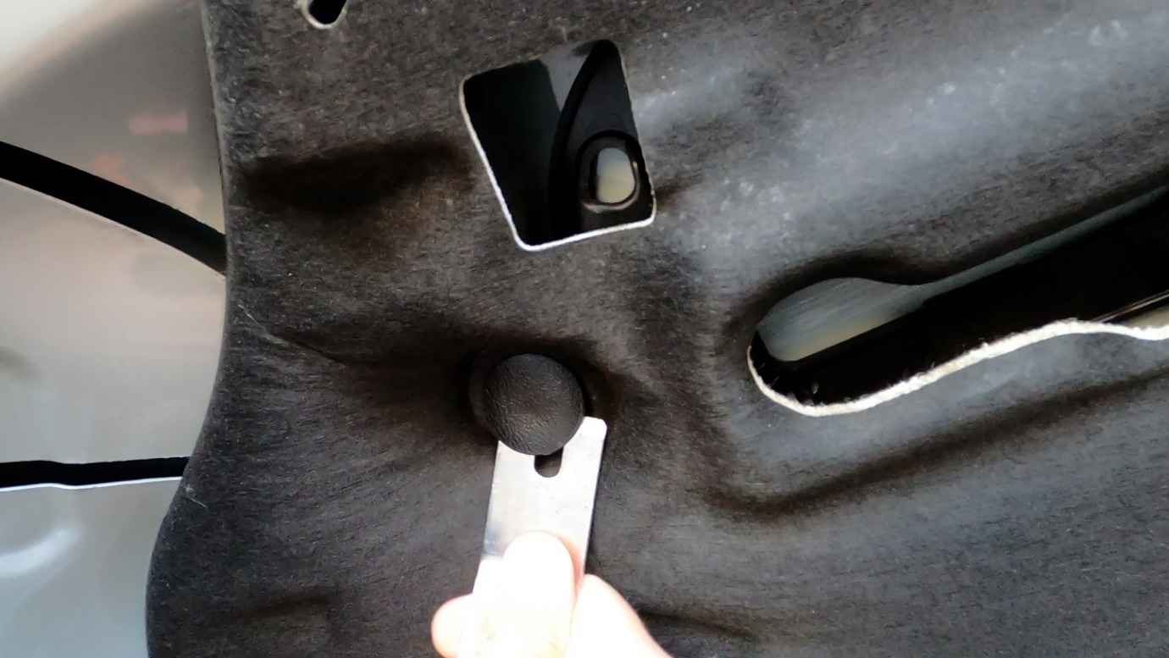
- Remove the center clips that secure windshield washer hose to bottom side of hood and put somewhere safe. You will reapply these at the end of the install.
- Disconnect them at the “T” (passenger side) and elbow (driver side). Hint: Twist the black plastic retainer counterclockwise to release.
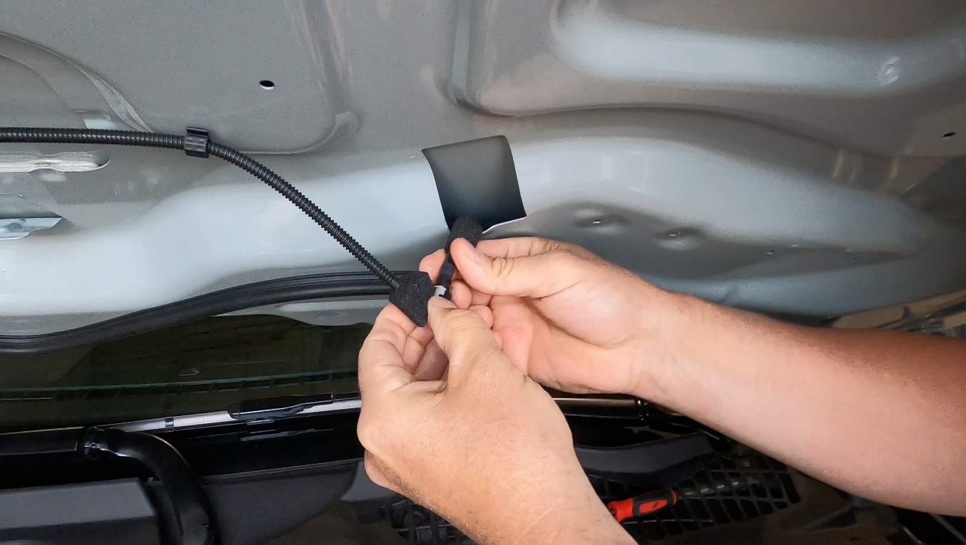
- Soft close the hood and wipe down with a window cleaner NOT detail spray.

- Tape a layout for the cut area in the center of the hood with the tape exceeding the width of the hood graphic.
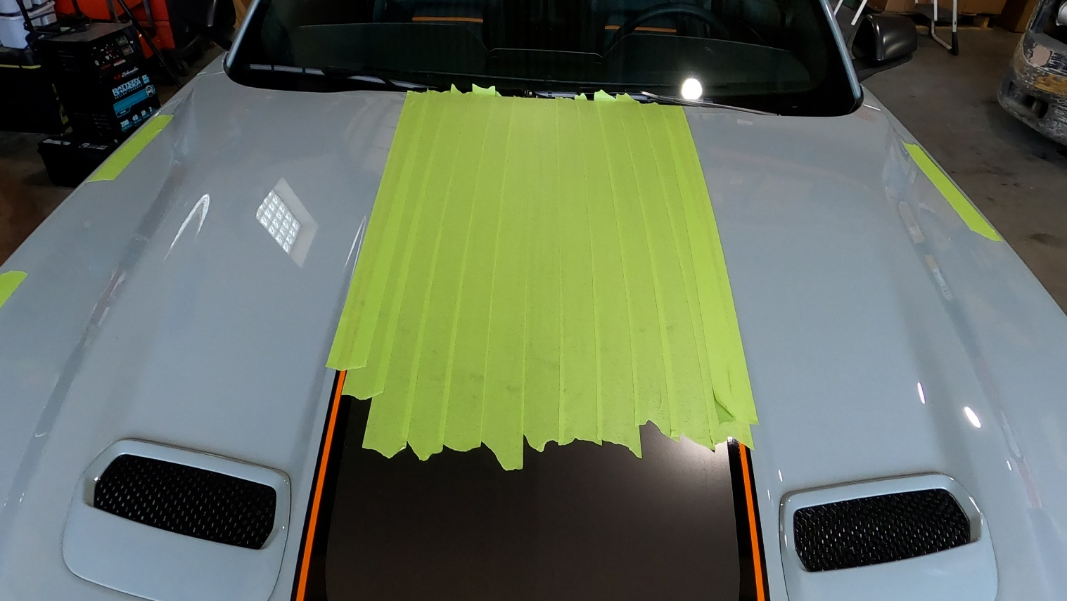
- Measure 16” from the corner of the fender where it meets the A-pillar and door jamb to the edge of the hood. It does not matter which side of the car you measure first.
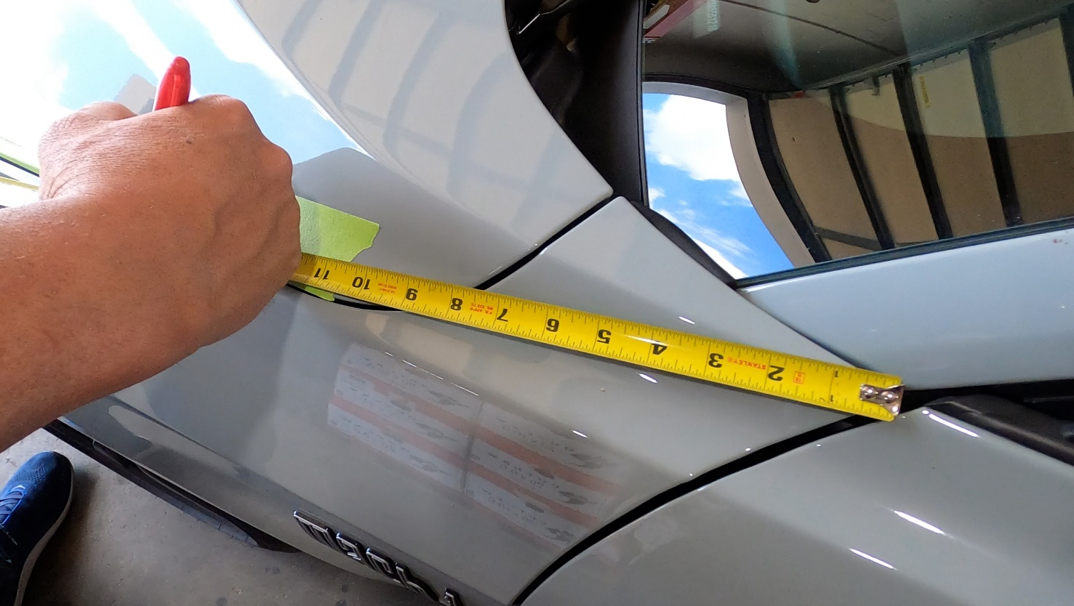

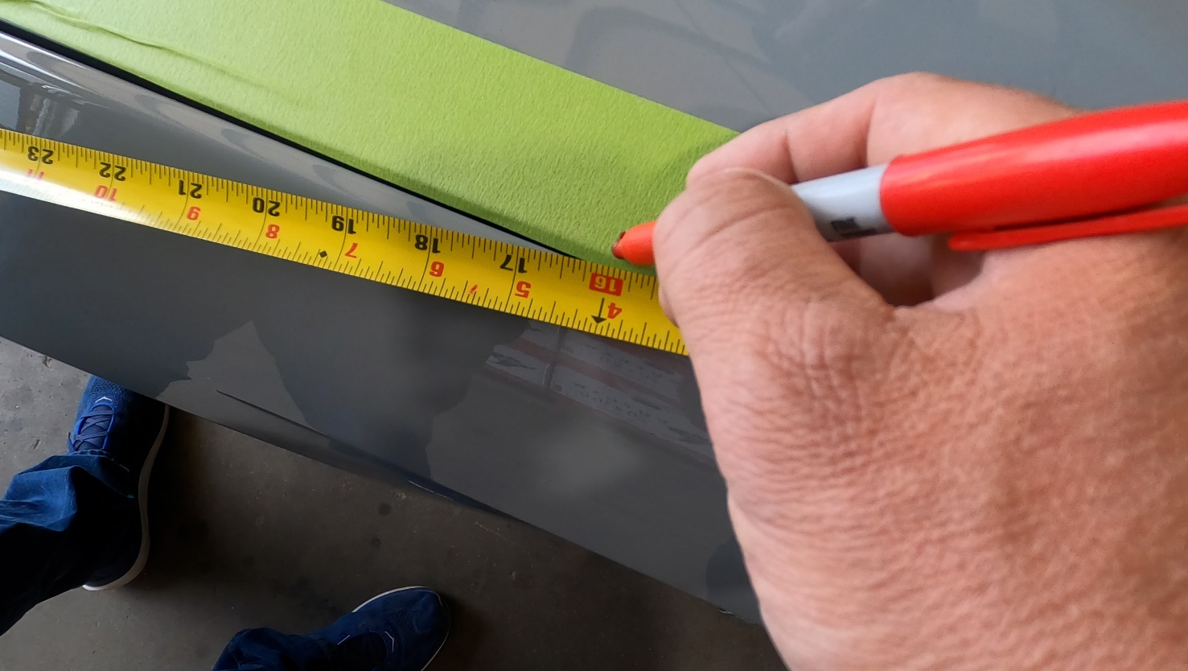
- Then move toward the front of the car and mark at 36”. Keeping the tape measure anchored in the same spot as when you measured the 16” mark.
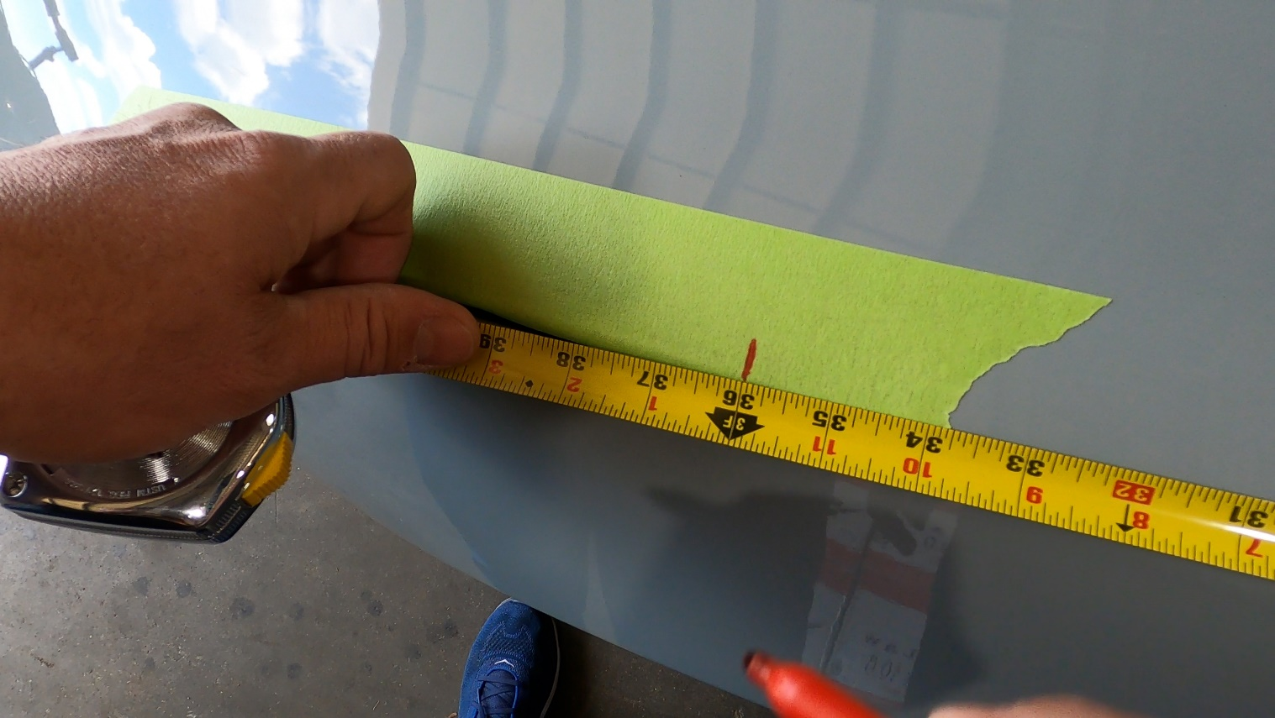
- Mark the same measurements on the other side of the hood.

- Start on the driver’s side and anchor your measuring tape at the 16” mark then go across the hood to the other 16” marking, find the middle and mark it. Then go to the passenger side and do the same thing and mark the middle. Now split the difference of these two marks.
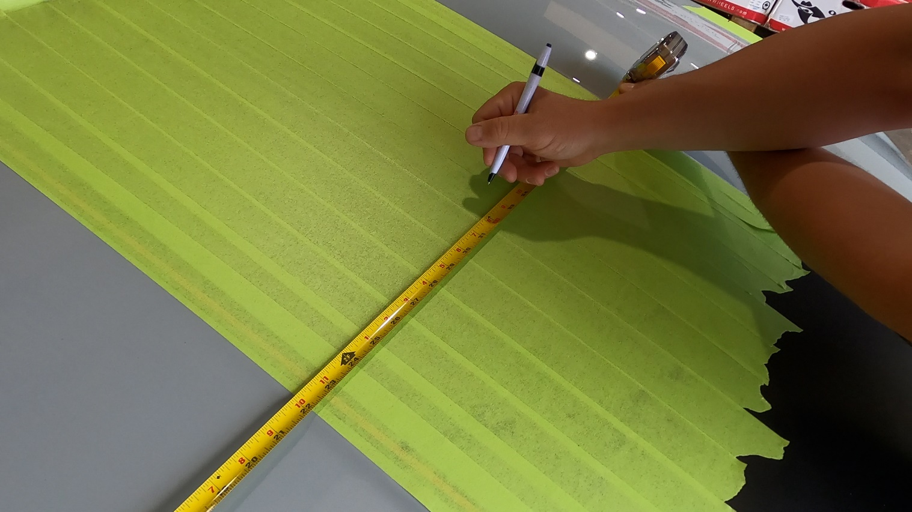
- Repeat step #9 at the 36” markings.
- Remove the provided template from the box and cut a “V” shape into the front of the template with the point of the “V” ending at the center of the Shaker hole cut line. Align the point of the “V” to the center line we just marked in steps #9 and #10.
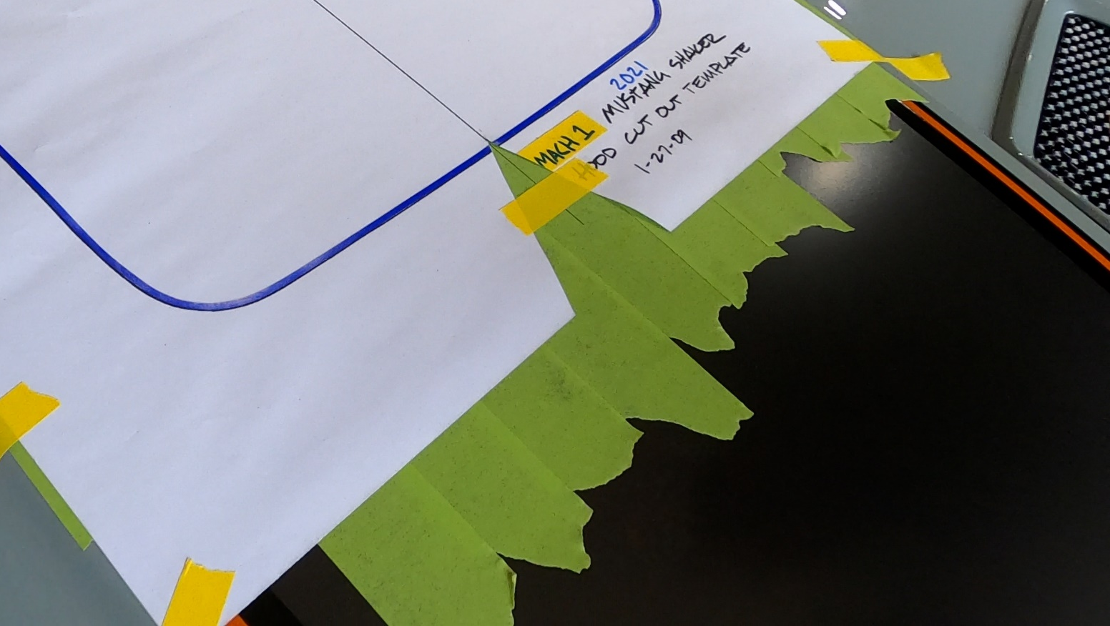
- Cut the same “V” shape into the center of the rear of the template.
- Now tape the template down in the center of the hood and 12 3/8” from the back (windshield) of the hood.
- Using an x-acto blade, cut on the line for the shaker hole. Press hard. You are not only trying to cut the tape beneath but also score the paint below it to avoid any chipping when cutting with the saw.
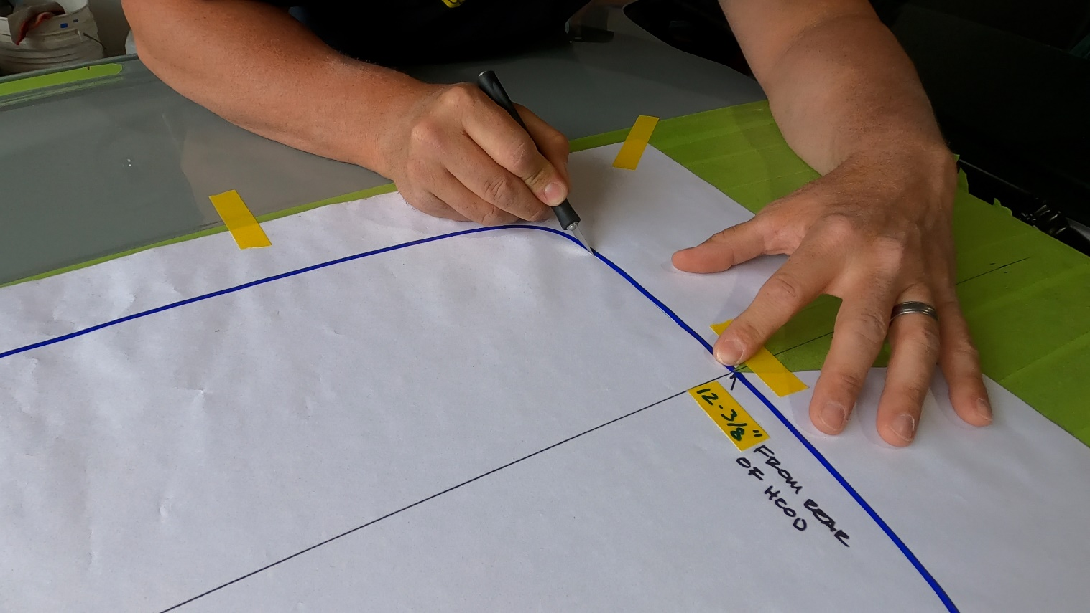
- Once you have completely cut the template out, remove all the paper and begin pulling up the tape. Only remove the tape from inside the cut area where the shaker scoop will be. You can re-stick the tape you are removing to the outside perimeter for extra protection when it comes time to run the saw over that area.
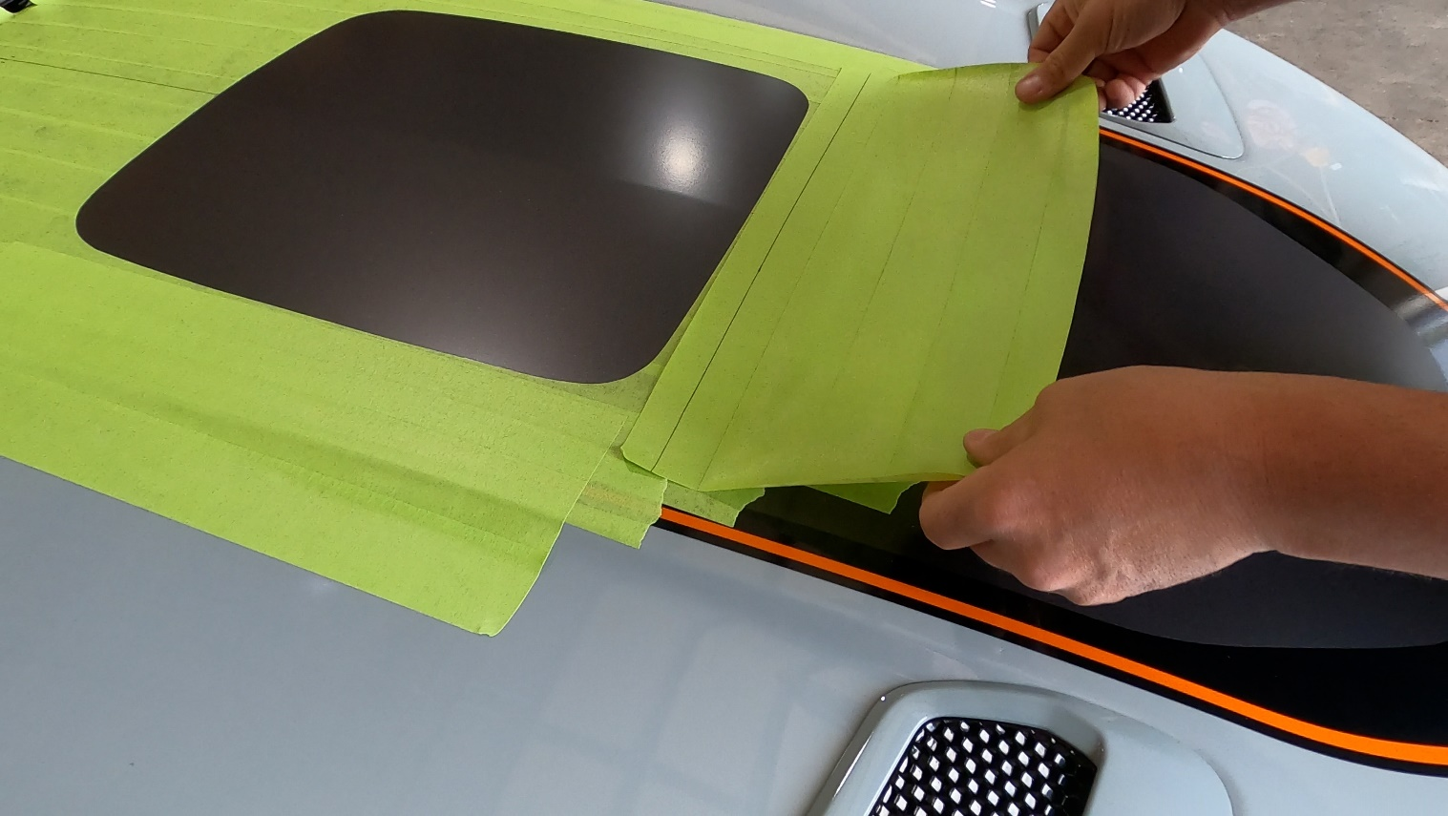
- Remove the hood graphic from inside the cut area.
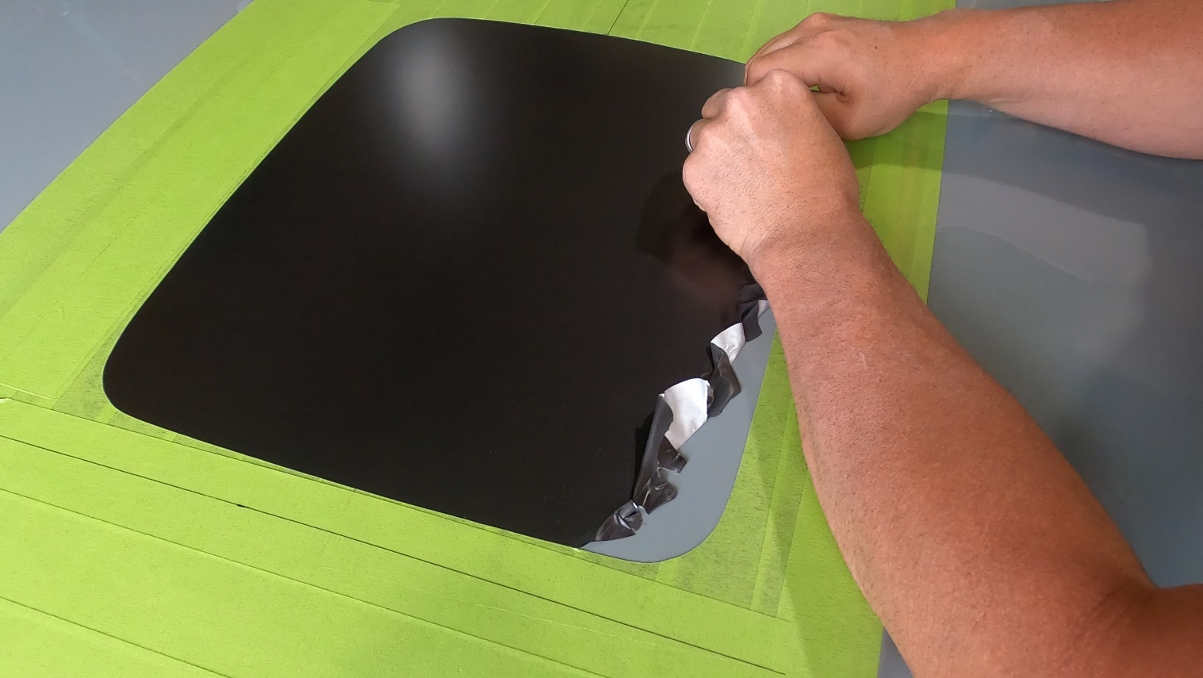
- Open the hood again and place a sheet or blanket over the engine bay. This is to prevent metal shavings from getting into the engine bay. Find a wedge to keep the hood flat and prevent it from closing (4x4 chunk of wood works great).
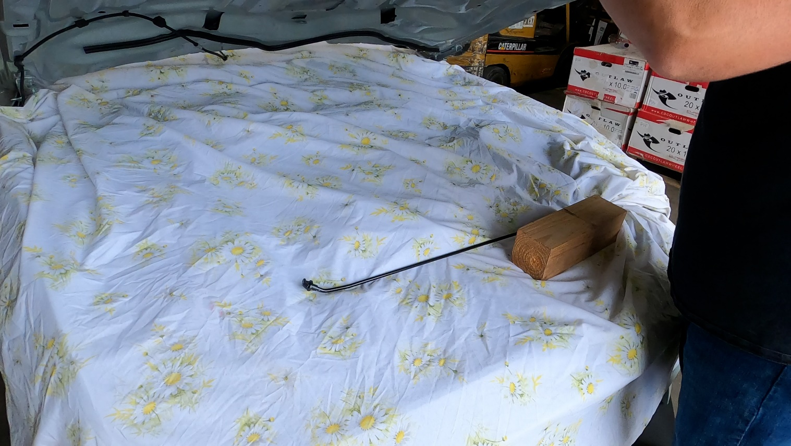
- Drill a pilot hole for the saw blade to enter using a step bit.
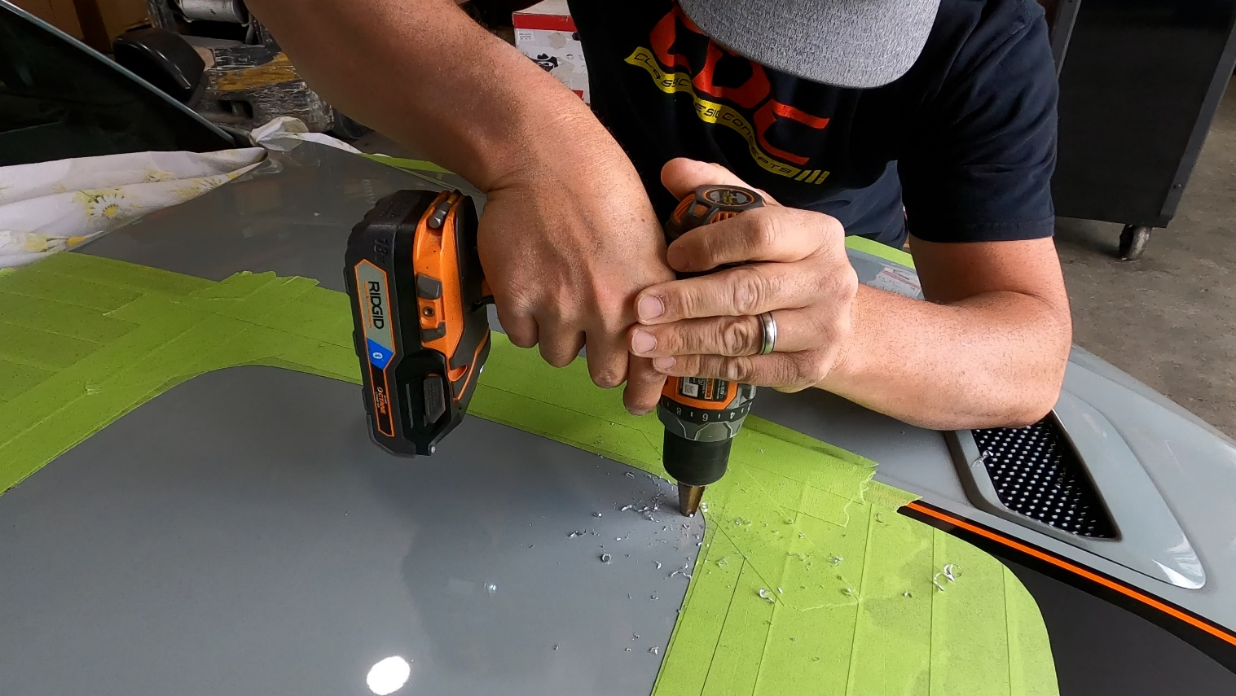
- Blow off the metal shavings from the hood surface.
- Begin cutting the Shaker hole with a jig saw. Pro Tip: use blade wax if available. This will help prevent aluminum from clogging the blade
  - After completing the first corner at about halfway to the next corner, pause to place a wedge (paint stir stick works well) beneath the corner to help avoid pinching the blade as you continue the cut. Place a new wedge as you proceed around the next corners.
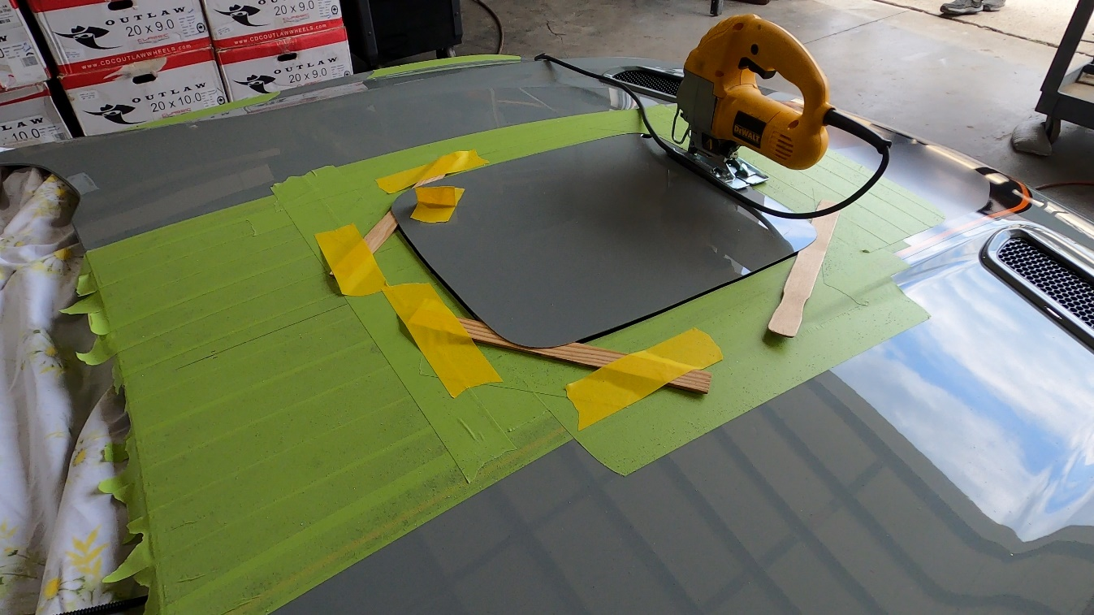

- Once the cut is complete. Remove the sheet from the engine bay, making sure to clean off any metal debris from the hood surface and engine bay areas.
- Remove (5) fasteners securing the air filter shroud. This will also require unplugging the sensor from the intake tube.
- On the back side of the housing (closest to the shock towers) measure 4” down from the top of the housing using the rear mounting tab as a guide.
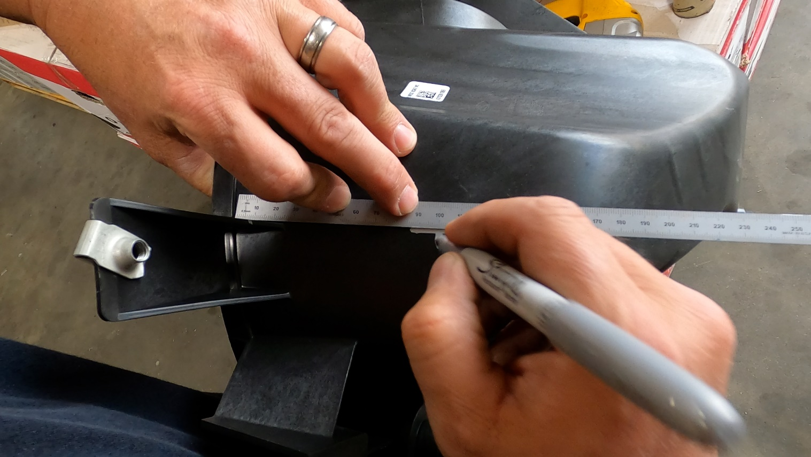
- Drill a pilot hole for the hole saw. Use a 3” hole saw to make a hole for the flexible intake tube.
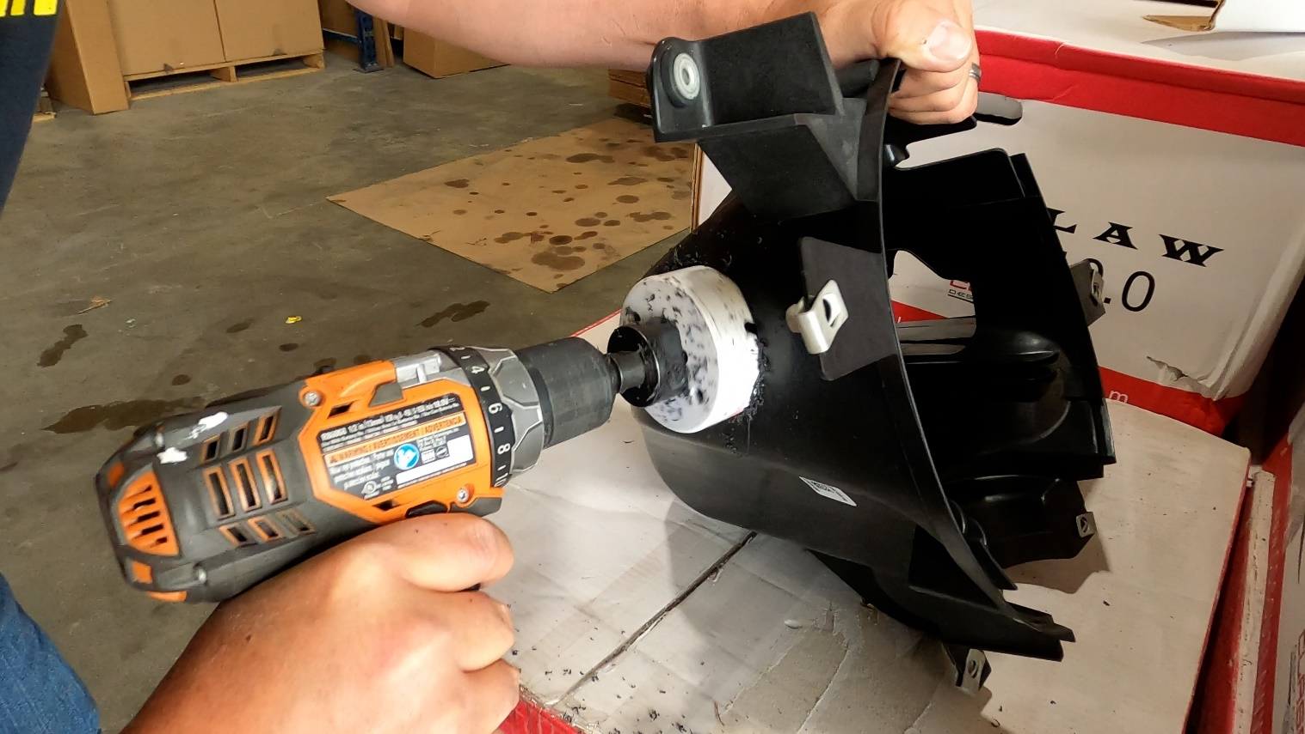

- Clean up the shavings from the hole and clean our any debris that might have fallen inside of the shroud.
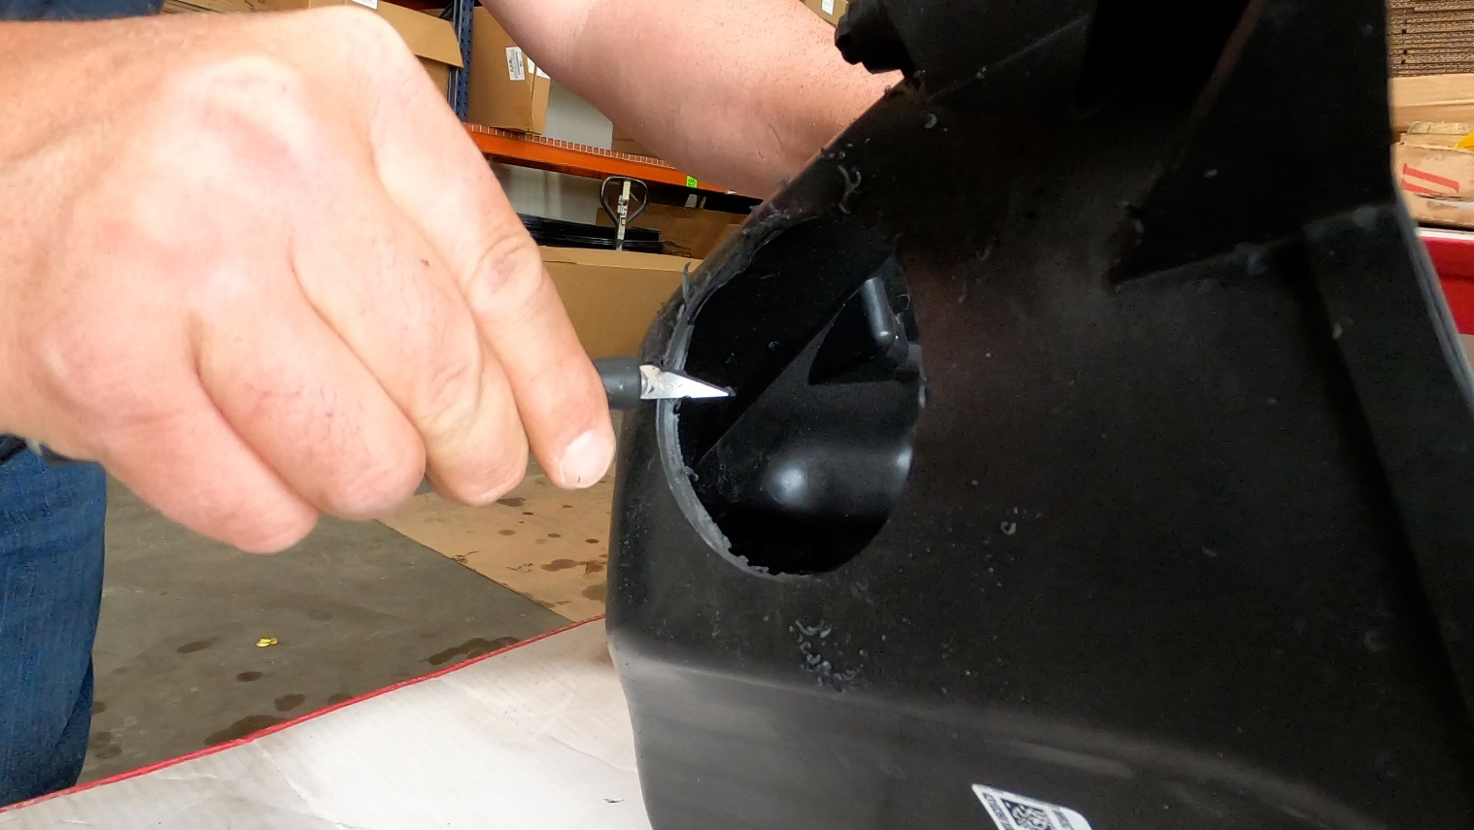
- Replace the airbox and plug the sensor on the intake tube back in.
- At the front of the intake manifold is a sensor and two vacuum lines.
  - Unplug the sensor.
  - Pull up on the black plastic retainer that secures the vacuum lines to remove it from the stud below.
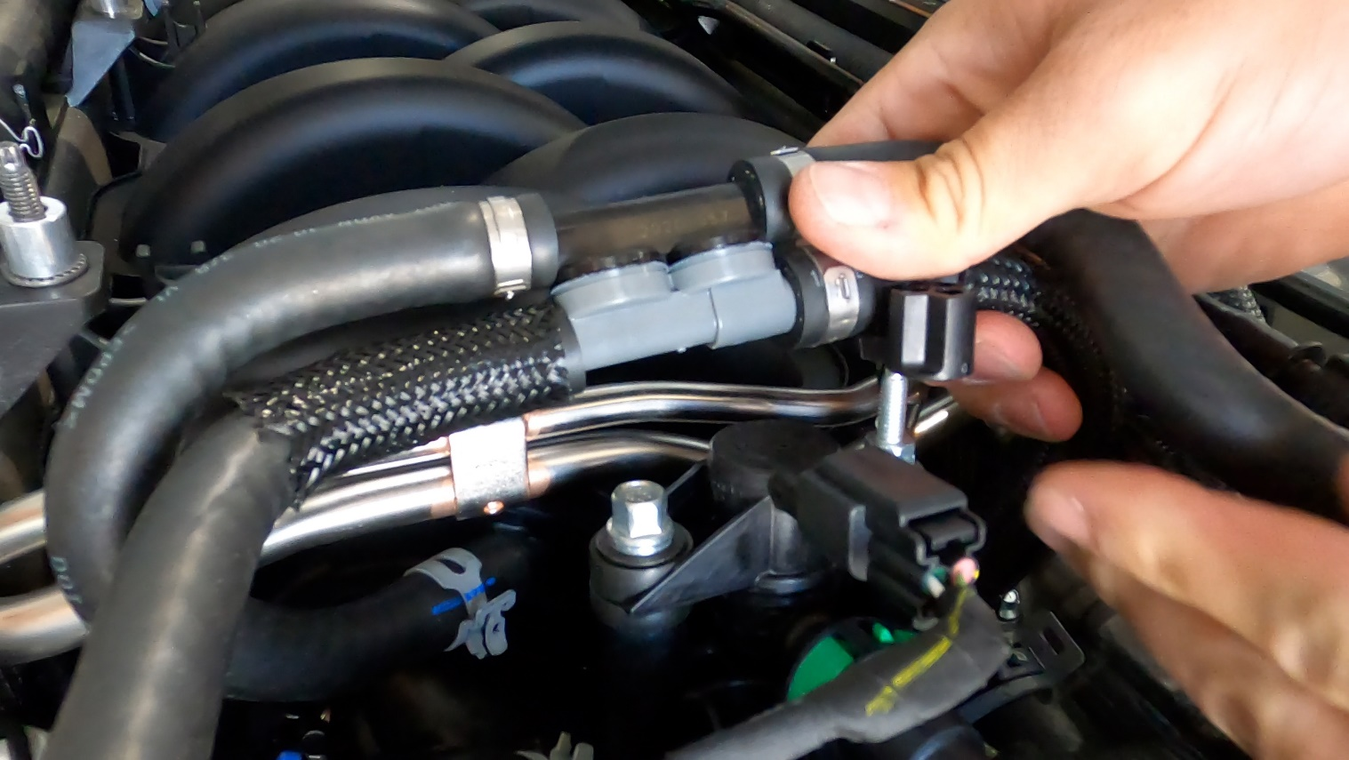
- Using a pair of cutting pliers cut the black plastic retained from the vacuum line and discard. Place the sensor receiver between the two vacuum lines and reattached the plug end of the sensor. This is to gain adequate clearance for the shaker manifold bracket.
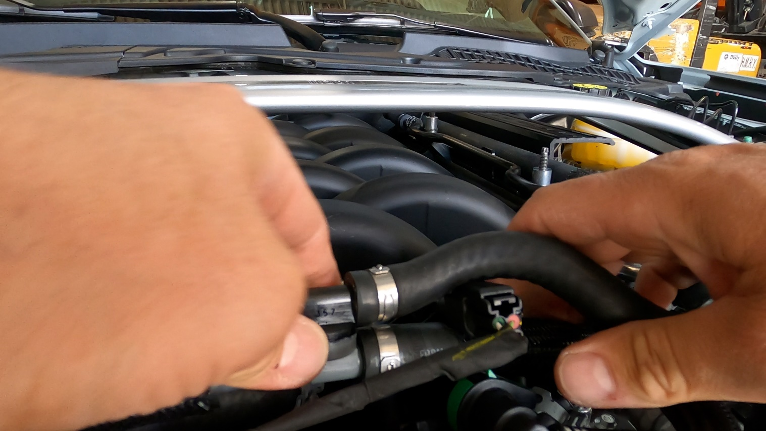
- On the driver side place a piece of tape on the “Powered by Ford” part using the front edge of the shock tower brace as a guide for the tape front facing edge.

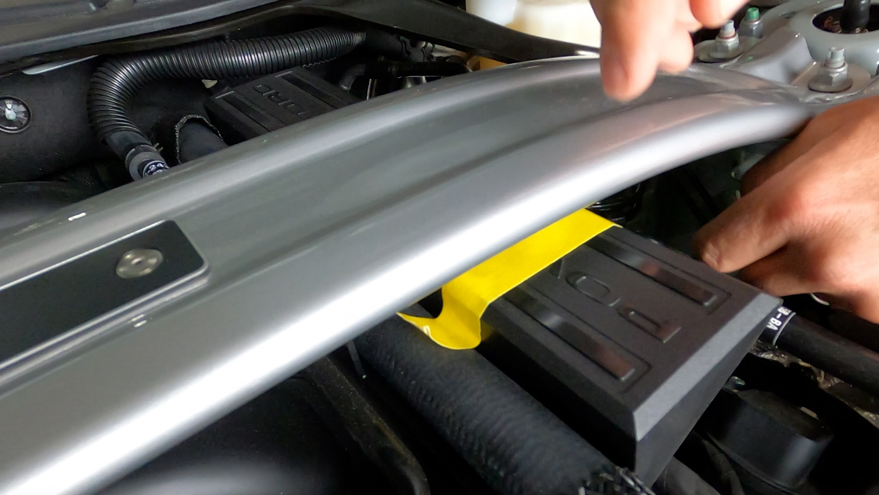

- Remove the “Powered by Ford” plastic part and using a saw cut off the smaller side of the plastic.
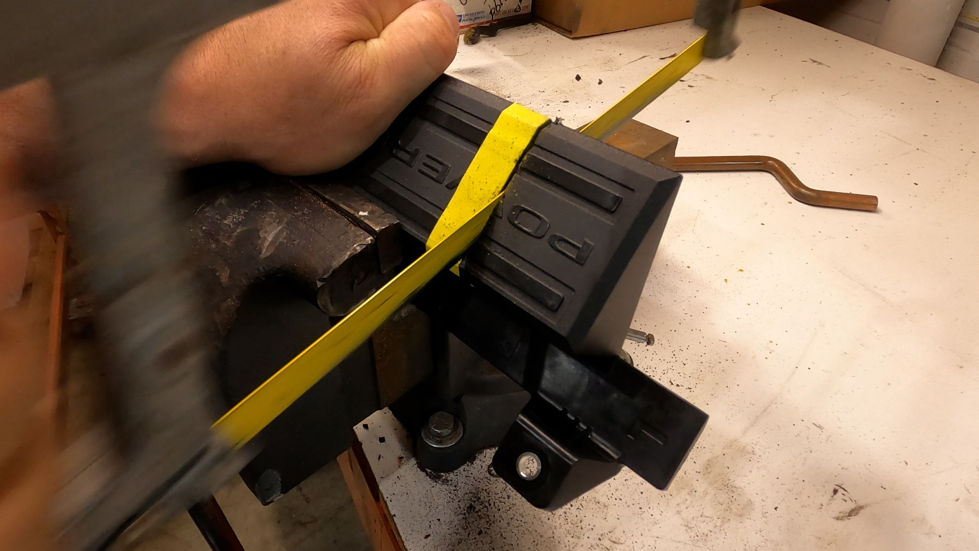
- Remove the (2) passenger side intake manifold stud bolts using a reverse Torx socket.
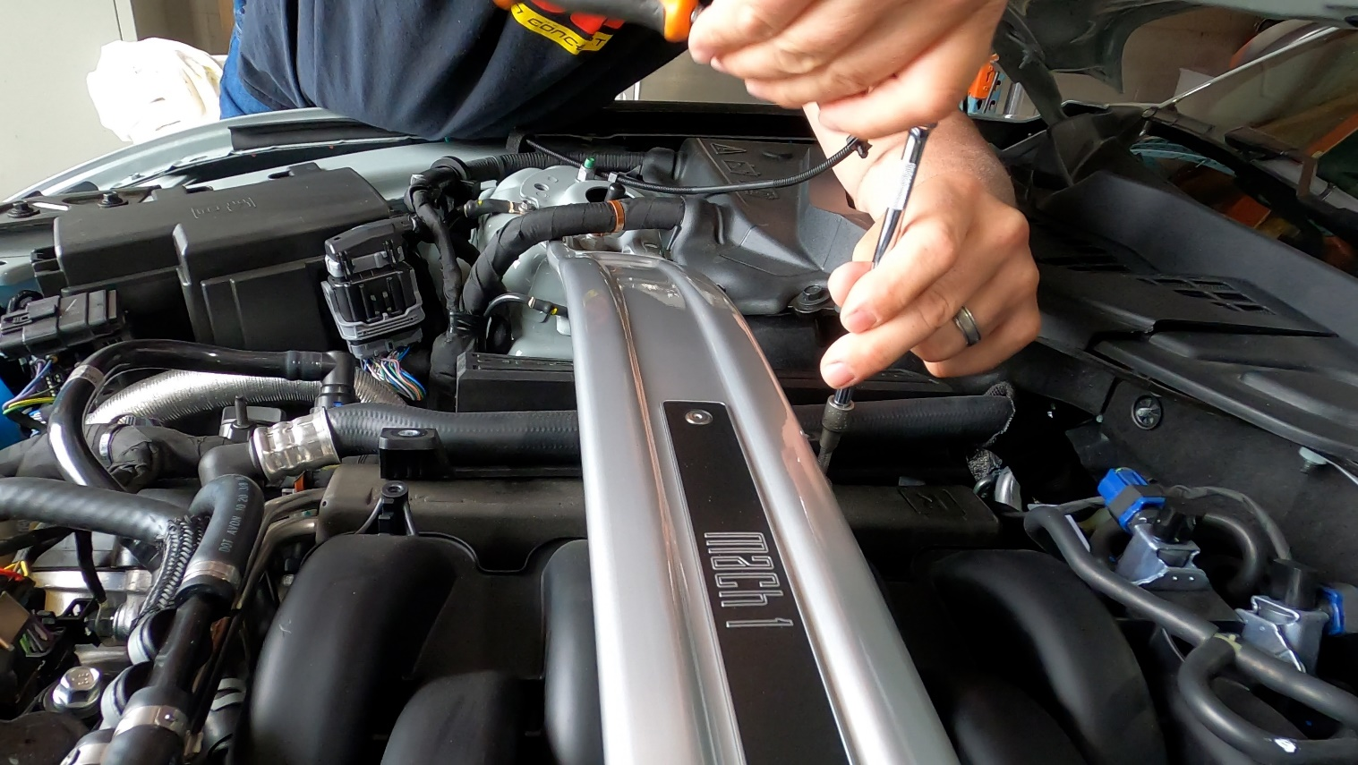
- Replace the passenger front stud bolt on top of the “Powered by Ford” part and WITHOUT a spacer between the plastic “Powered by Ford” part and the stud bolt.

- Replace the passenger rear stud bolt WITH a spacer #57004 (.375”) between the stud bolt and the plastic “Powered by Ford” part.
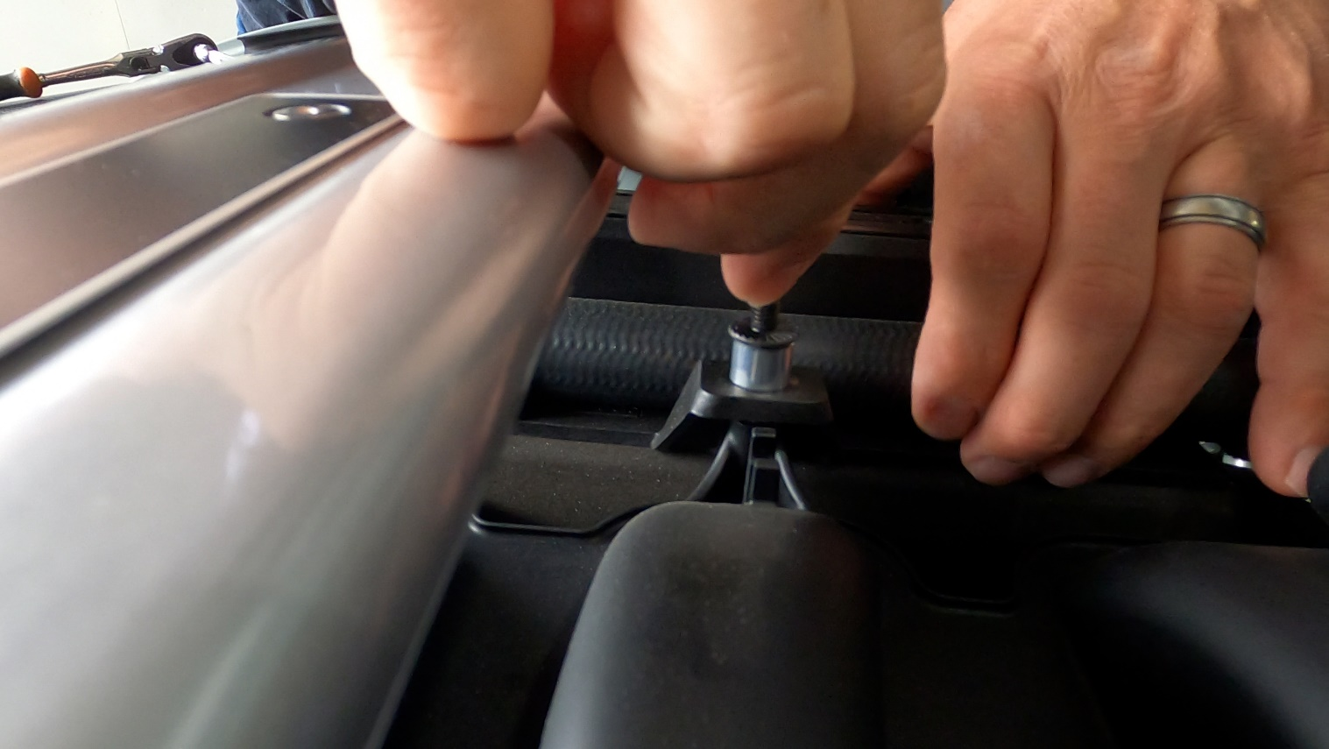
- On the passenger front stud place a spacer #57002 (.482”) on top of the stud flange.
- Repeat previous step to the passenger rear stud with one spacer on top#57002 (.482”)
- Reapply the driver rear stud placing spacer #57005 (.242”) between the plastic “Powered by Ford” part and the stud flange as shown in step #27. Next place spacer #57002 (.482”) on top of the studs flange. Replace the Driver Front Stud WITHOUT a spacer between the plastic the stud bolt. Place spacer# 57003(.4375) on top of the stud.
- Use an 8mm to remove the two black bolts from the lower black bracket from the shaker assembly. The other end of the bracket is secured by ball studs and will pop out of the socket area with a firm yank.
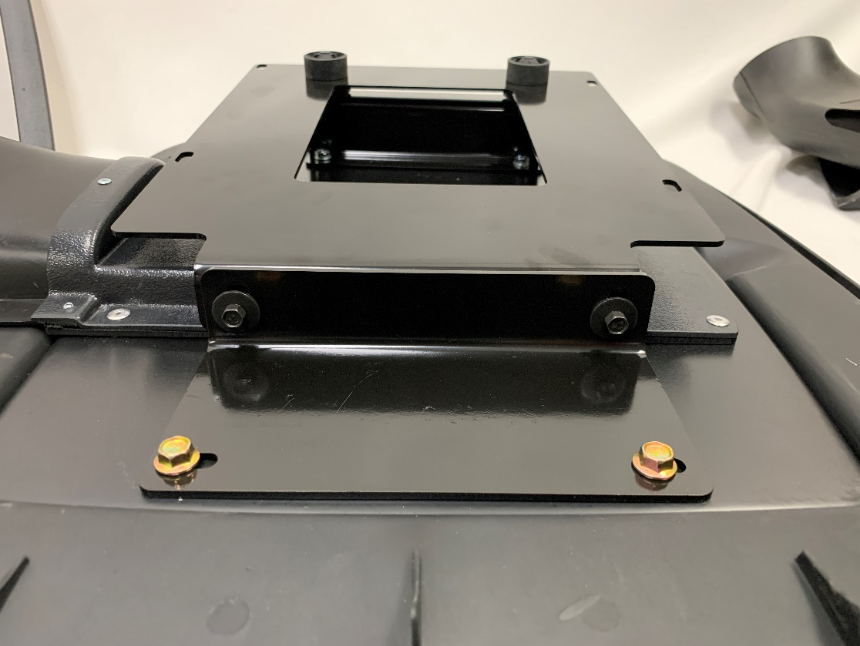
- With the bracket free from the rest of the shaker assembly, place the bracket on top of the manifold studs and hand tighten the nuts on to the four studs. These nuts are from the “Powered by Ford” studs and originally on the car.
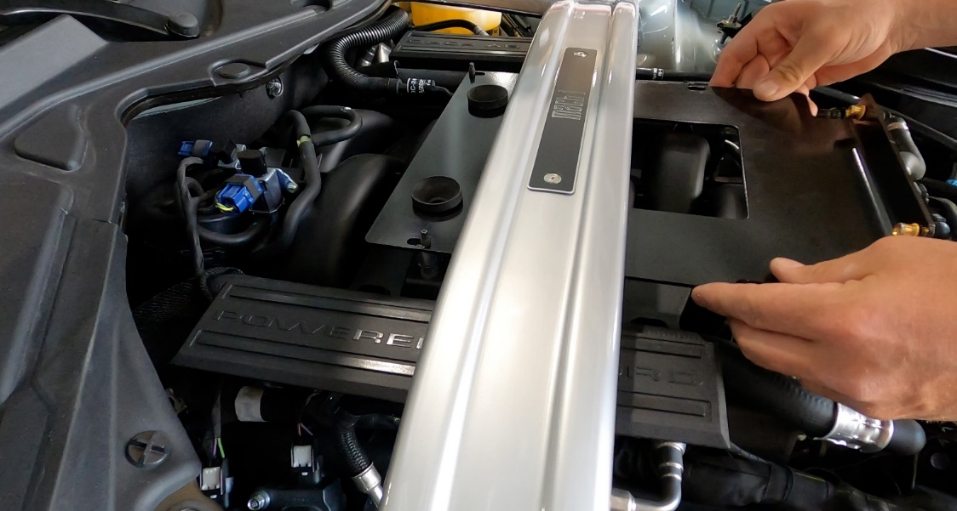
- Next is to “dry fit” the scoop position in the hood hole. First, place the rest of Shaker scoop assembly on to the bracket then push ball studs into the joints. Safely close the hood. There is about 1/8” of forward/back adjustment in the slots on the bracket for you to make any adjustments.
- Once you are satisfied with the position in relation to front and back gaps of the hole, remove the scoop portion of the shaker assembly again. Give a final tightening to the nuts securing the bracket down. Replace the scoop portion of the shaker assembly and reapply the bolts we removed in step #37.
- On the driver side of the shaker assembly, attach the flexible air tube to the shaker intake tube using the rubber coupler. Fit the other end of the flexible air tube into the air box shroud where you cut the 3” hole.
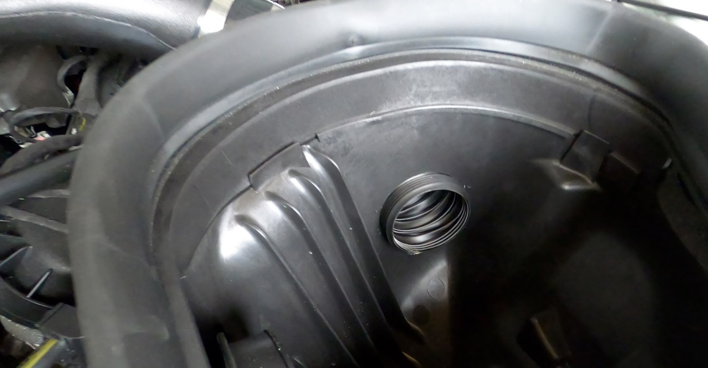
- Close the hood.
- Take the trim ring and dry fit around the hole. Then remove the trim ring again.
- Clean the perimeter of the hole with the provided alcohol wipes.
- Peel a 2” portion of the 3M tape on both sides and fold them outwards. This will give you a tab to pull along as you stick down the trim ring to the hood.
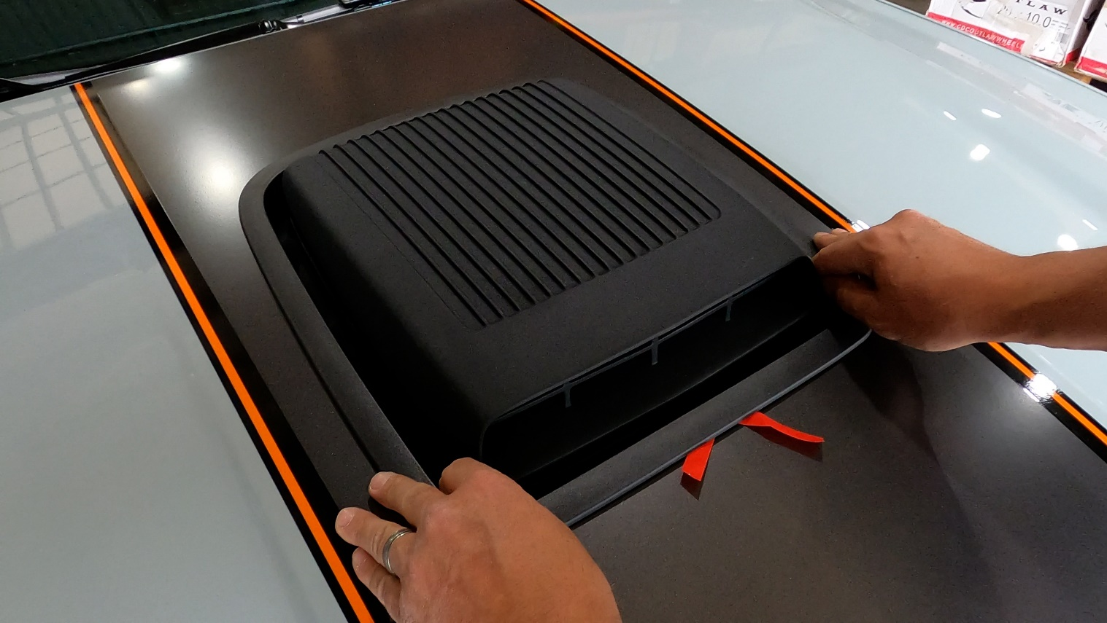
- Start pulling the red tabs along the bottom of the trim ring. Work only a few inches at a time, stop to push down then do the same on the other side. You will want to work up both sides simultaneously until the tabs meet that the top center.
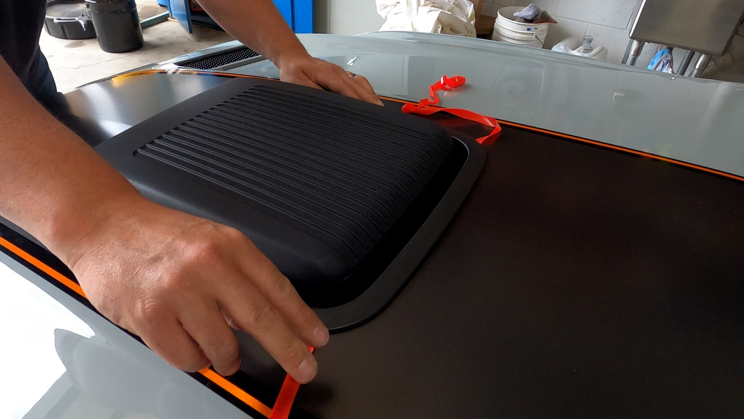
- The tape is pressure sensitive so make sure to spend time pressing down firmly along every inch of the trim ring. Open the hood and pull into the trim ring as well.
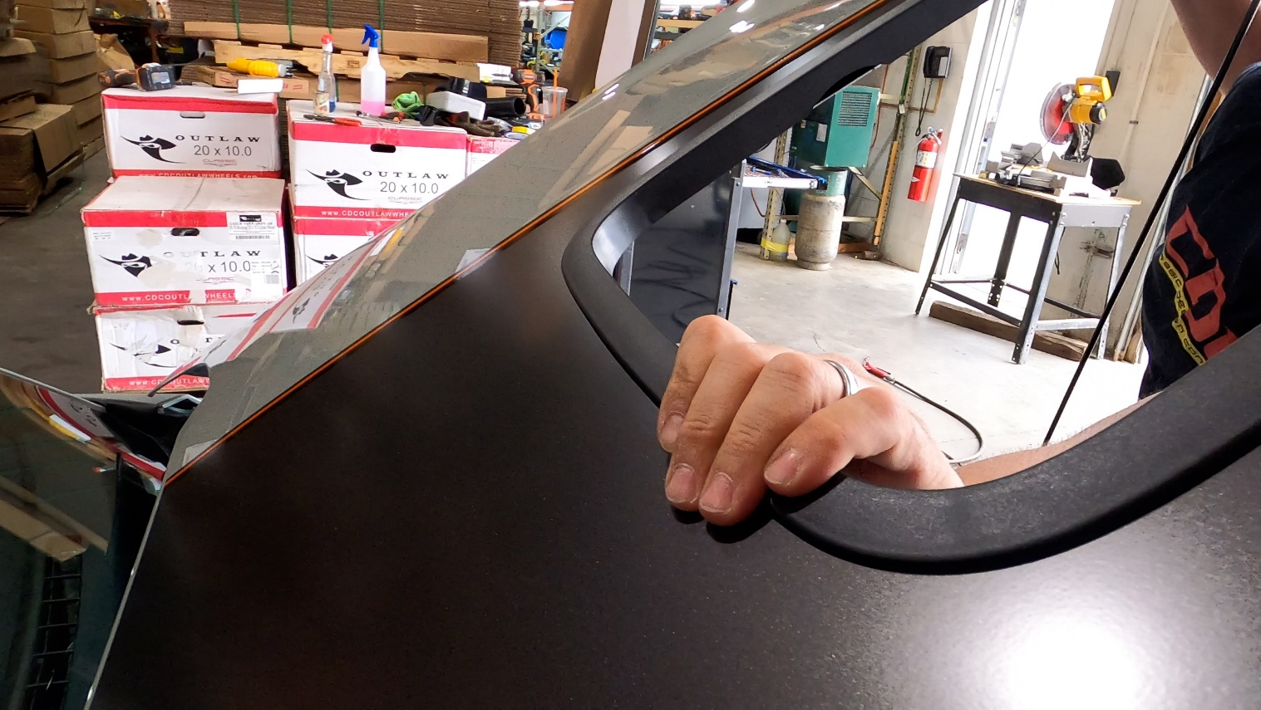
- The next step is to reroute the squirter lines we removed earlier in the installation.
- With the hood opened, find the tab near the center of the hood between the shaker hole and the windshield. Pry the tab down a ½”.

- Drill into the tab using a 1/4” drill bit. EXTREME CAUTION: do not let the bit crash into the bottom of the hood. It will dent the surface of the hood. (a step bit may be easiest method)
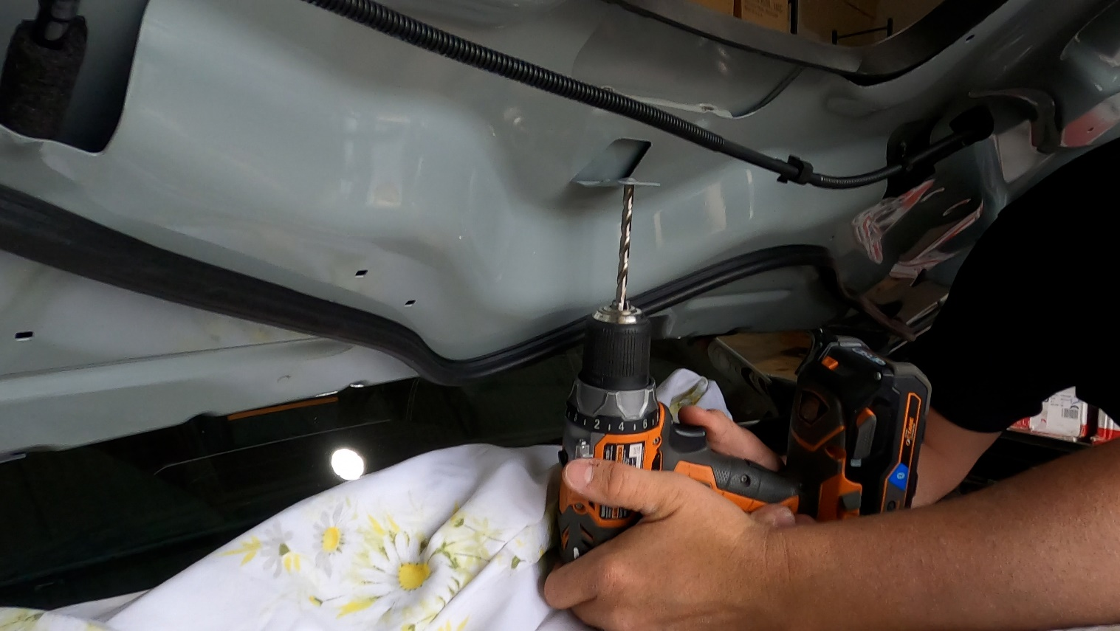
- Move one of the black “Christmas tree” fasteners on the squirter line to align with the hole. Push the Christmas tree into the newly drilled hole.
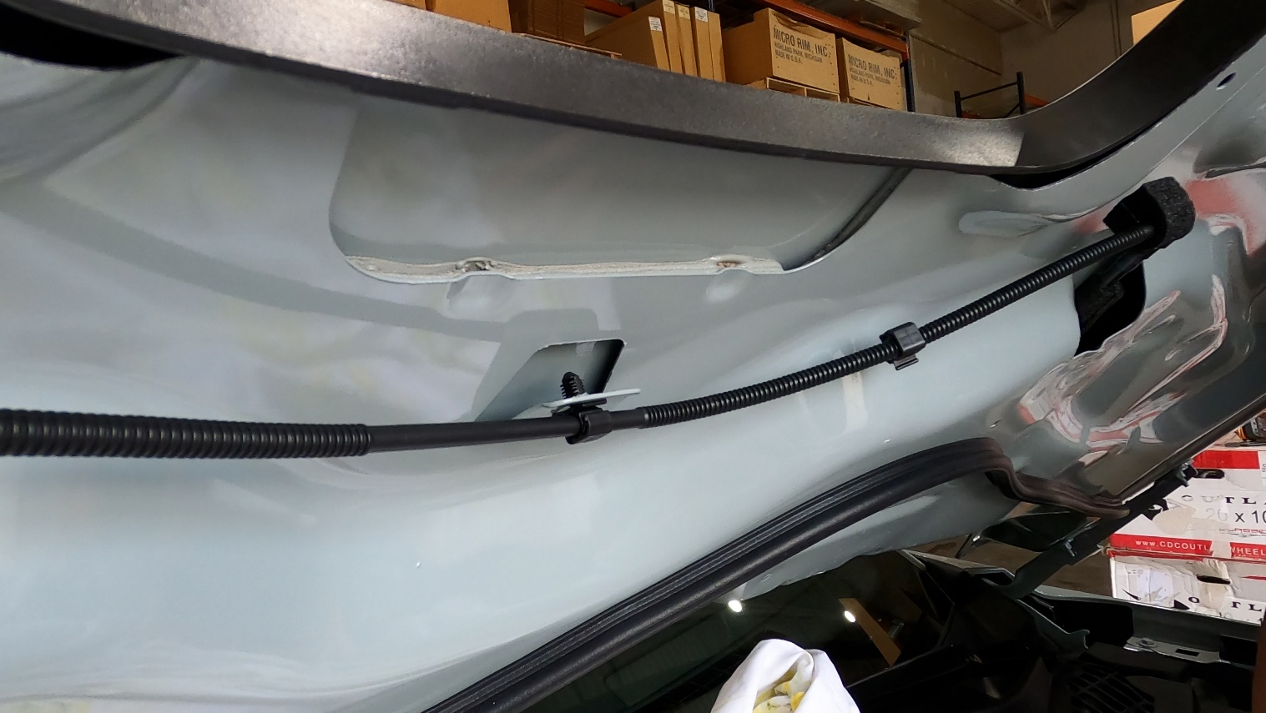
- Close the hood and go for a drive to enjoy the view of your new Shaker Cold Air Intake System from the driver’s seat.
- Send us some pictures of your completed install @classicdesignconcepts on Instagram, CDC- Classic Design Concepts on Facebook or email them to us, sales@cdcdetroit.com

